LOVE AND LOVERS

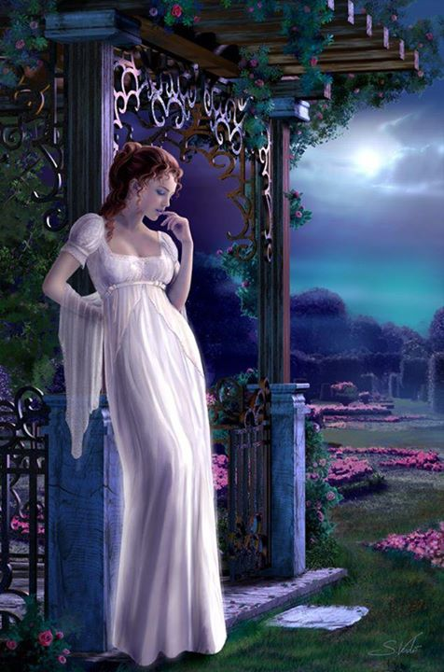

What the winter has done to the blossoms of the fields
I have done to you.
What the autumn has done to the blooming gardens
You have done to me.
I caressed you the way
The lands sought the streams
You embraced me
As the ripples have embraced the banks.
My endeared, the love we have
Are we lovers or corals?

May be the Lotus have opened
Their eyes before I have seen you.
May be the moon has arisen before,
I started talking to you.
I never knew anything,
Till you have fulfilled in me.
My thoughts are the Lotus pond
And my dreams are the milky way of the moon.
What kind of love is this my beloved?
Me the honeyed moon and you the Lotus pond?

May be the flowers started blooming
Before I knew you.
May be the doves have been flying in the sky
Before you diffused in me.
I knew nothing till I first met you.
When did the flowers bloom in me,
And the doves commenced crooning in me?
What is this love, my precious?
Are we the blossoms or the white doves?

I have seen in my dreams those lovely dales,
Those dreamy vineyards
Those chavok trees on the hills,
The tiny springs that forms the stream
The roses that clad the slumbering hills,
like blankets
The soul of the pink sun kissing the lovely mounts...
What kind of love is this, my beloved?
Are you the mounts and me the kissing sun?

Whatever I have sung all this time
Was about you, and around you.
Whatever I was seeking
Were the paths you stride on.
Till this moment there was no moonlight for the day.
From now onwards each evening will be
Resplendent with the love of the sun
And the moon merging together.
What kind of love we have beloved?
Are we now a pair of swans?
Swimming in the pond of love?

We are the birds chirping
In the nest of a tree, somewhere.
We are the blue blossoms on the hillside
Let the tree, its branches
And the nest remain perpetually
Let us not shrivel away the blue flowers.
What is this love, my beloved;
Are we the blossoms and the birds?

No forests, no deserts
In the land I wake you up, there is no roof;
The floor is not paved
Where I am making you sleep,
I am there, with enough of my retrospections
There is rain underneath the sky you are
With the flowery rainbow, and the stars to keep company.
What is this love my beloved?
Are we the stars that fell in the earth?

I have seen the depth of the sea,
And its bluish tinge in your look.
I heard in your words the ocean
Of love and tenderness.
I sang in an unknown language
In a tune we have never heard.
I drew unseen pictures
In colours that bears no name.
What is this love my beloved?
Are we those pictures we painted?

My love for you is the yearnings
for me to live more
And your loving me is the inner truth of my life
While I wait for your coming,
My shadow will always accompany me too.
May be our shadows were also lovers as we are
What is this my beloved?
Are we dragonflies of love?

Did those hilly ranges hear our talk about love?
Did anyone in this garden see our sharing of love?
Let the hilly ranges of this area be deaf without ears.
And those earthen lamps blind and without eyes.
What is this, my beloved
Are we those bowers which never tasted the summer?...

You have taught me to remember only you
You taught me drawing near to you and love you much.
Are not you the distance separating the strand and the horizon
Are not you the depth of the sea in a conch of the ocean.
What is this my darling,
The oyster in me has rendered a white pearl?

The flowers and butter turned like petals
In us and blossomed as love.
Like the nectar dripping from petals
It sweetened our relation of love.
The love in us has till now dispersed its fragrance
We are the floret and should never wither
What is this my beloved,
Are we eternal lovers in this earth?

