Legendary love
( Love Tales and love events in verses)

Rm Shanmugam Chettiar

CONTENT
Oedipus (430BC) 4
Cleopatra’s Glory (69BC to 30 BC) 6
Pyramus and Thisbe love (8AD) 9
Helen Of Troy (AD 500) 12
Layla and Majnun (500AD) 16
Andal, the mystic (800AD) 19
Radha is an enigma (1100AD) 21
Tristan and Isolde, a tale (1200AD) 22
Lancelot-Guinevere love (1300AD) 26
Padmavathy, the queen of Chittor (1300 -1400AD) 31
Chittor Rani Padmini (14th century) 33
Anarkali (late 16th century) 36
Pride And Prejudice 39

Heloise (1079-1142) and Abelard (1101-1164) in love 41
Josephine Napoleon (1763 – 1814) 45
Barrett and Browning in love (1806–1861AD) 48
Jane Digby- the pursuit of love (1807-1881AD) 50
Mata Hari (1876-1917AD) 53
Mohammed Ali Jinnah’s fall (1876-1948AD) 54
Edwina Mountbatten (1900 – 60) 56
A doe eyed Bengali beauty (1928-2014AD) 59
Jacqueline Kennedy Onassis 1929 – 94 61
Prince Margaret ever young. (1930-2002AD) 64
Divorce and remarriage (1932-2011AD) 67
Sophia Loren (1934AD) 69
Ratna Sari Dewi Sukarno (1940AD) 71
Marilyn Monroe. (1945-62AD) 74
Hollywood, a catching pouch 76
Apples cast off (1975AD) 78
Oedipus (430BC)

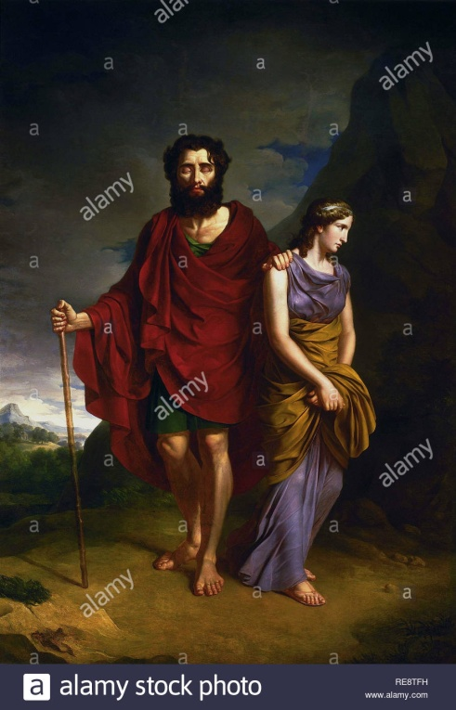
Oedipus was king of Thebis;
Jacarta was wife of Oedipus.

Oedipus was sincere in his duty.
‘While you suffer, none suffers more than I’,
With this, he resolved to save the city
By finding out the killer of King Lains.

Teiresias, a blind prophet, accused him,
‘You are the cursed polluter of this land.’
‘Terrible things indeed’ has the prophet spoken,
The killer of King Lains shall be banished’

The tension mounted and the truth revealed.
He was the son of King Lains whom he killed.
He married the king’s wife, Jacasta,
Without knowing that she was his mother.

Crippled with ignominy for the killing,
Oedipus preferred death but banished himself
As the banishment was the cure of the city.

Jacaste loved Oedipus and believed in chance.
‘Chance rules our life and the future is all unknown.
Best live as best we may, day to day’
She could not allow him to be doomed.

Oedipus must not know about his origin,
Which would reveal her relation to him.
She met her death, a proper end of incest.
Feb., 2008

Cleopatra’s Glory (69BC to 30 BC)
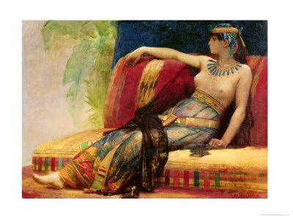

Cleopatra was the queen of Egypt;
Cleopatra was the queen of beauty.
She came to the throne at her eighteen
The first century BC witnessed it. 1

To get back her Egypt from her brother,
She sought the hand of Julius Caesar,
The mighty one Rome had ever seen,
And set to sell her asset of beauty. 2

While in exile, she was able to reach
Caesar when he chanced to visit Egypt,
By getting her smuggled into his room,
Rolled up in a carpet sent as a gift 3

Cleopatra emerging from the roll,
Caesar was stunned and fell for her in love.
He made her queen of Egypt in no time,
And made her his consort with all respects. 4

Bound by her charm, grace and wit together,
Caesar clued to her and bore her a son.
He brought her home to be adored by Rome.
They led a life, each proud of the other. 5

The rise of Caesar was the cause of his fall.
His rise in power and love for Egypt
Were good enough for his conspirators
To rise and annihilate him unaware. 6

Cleopatra with her son fled to Egypt
And Mark Antony succeeded the throne.
No wonder, her beauty arrested him.
No wonder, his valour imprisoned her. 7

The Rome emperor and the Egyptian queen
Loved, like of which no pair ever did.
The spring sprang, love spurted, and the passion flowed.
She was all and she was the world for him. 8

He took to Egypt and slept with the queen.
His rivals from Rome used his weakness,
And invaded the Egyptian sea.
War broke; Antony woke and fought but lost. 9

The majestic queen became the captive.
False news spread that she was killed. Shocked,
Antony killed himself with the sword he wore.
She sought to burry him with state honour. 10

She heard she would be taken to Rome,
To be chained and drawn in Rome she adorned.
Romans took care that she killed not herself,
And they kept her well safe amidst water. 11

She had serpents brought in the fruit basket
And had them sting her to join her lover.
She loved Caesar and lived a royal wife.
She loved Antony and lived a loyal wife. 12

A woman can love as much in succession.
Widowhood is not an impediment
And the land after the harvest is not waste.
Cleopatra is a perfect example. 13

‘Age cannot wither her, not custom stale
Her infinite variety; other women cloy
The appetites they feed, but she makes hungry
Where most she satisfies.’ W. Shakespeare
Apr., 2008

Pyramus and Thisbe love (8AD)
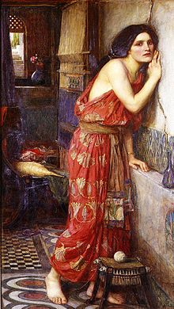
Pyramus and Thisbe were close neighbours.
Pyramus and Thisbe were intimate lovers.
His parents and her parents were rivals.
They lived in the city of Babylon.
The houses connected by a common wall,
Both families were near and hence hostile.
Pyramus was handsome and Thisbe, pretty;
They were growing near, and hence fell in love. 1

Pyramus and Thisbe were forbidden to love.
Because forbidden, they were attracted.
Pyramus and Thisbe were prohibited to talk.
She found a way to talk to her lover.
She found a crack on the wall dividing
The twin houses, and threw a stone to draw
His eyes and both whispered love each other. 2

They fixed their tryst one day near Nina’s tomb
Under a mulberry tree for being together,
And to transact their feelings for each other.
Thisbe arrived the spot a little earlier,
By when she found a lioness with her mouth
Bloody from a recent kill, approaching.
Terrified at the sight she fled the spot,
Her clock slipping down behind her by then. 3

Pyramus arrived a little later
And was horrified at the shocking sight
Of his sweetheart’s clock, which the lioness had torn
And left the traces of the blood behind
All along the track, to instantly conclude
That the lady had been devoured by some beast.
Pyramus killed himself, falling on his sword-
A Babylonian way of suicide. 4

His killing himself had caused a splash of blood
That stained the white mulberry fruits dark purple.
After a while, Thisbe came back to the site,
Where she saw Pyramus body in the pool of blood.
Racked with uncontrollable agony,
She took her lover’s sword and threw her body
Onto it and ended her life with him.
The deaths of the both are the play of fate. 5

With her dying breath, she pleaded with the gods
That be in a single tomb their bodies
And that the mulberry trees in that site
Bear fruit in the hue of dark and not white,
In the memory of their tragic love.
Mulberry fruits turn dark when they are ripe.
Ovid’s is the oldest surviving version
Of the story published in 8 AD. 6
June, 2020

Story Location Clue: The story of Pyramus and Thisbe is remembered in the mosaic displays of Paphos. This city is located west of the Troodos Mountains.
This tale was the inspiration for W. Shakespeare to write play Romeo and Juliet.

Helen Of Troy (AD 500)

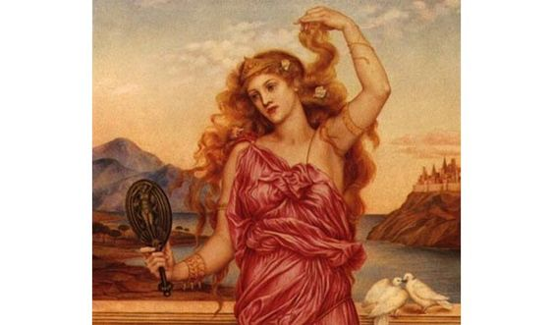

A mythological beauty, she had been;
A legendary beauty, she had grown.
Who is it other than Helen of Troy,
The epitome of seductive beauty? 1

A symbol of man’s erotic desires,
From the other women, Helen differs
In that she never employed her charms
To gain power of self-aggrandizement. 2

Her era dates to fifth century B.C.
The fairest of women had been the one
Whom all women should hate and yet envy,
And all men should fear and yet desire. 3

No wonder, men were captive of her charm,
But not was she captive of any man.
She had admirers; none did she admire.
Her fairness deserved more than what she got. 4

A puppet she was in the heavenly battle,
Where Greek Gods and Goddesses had sported.
As such, she must be absolved of the taints
She was attached with, sadistically. 5

Helen was the daughter of Zeus and Leda,
The Greek God and Goddess. Born of an egg,
And brought up by a shepherd, she became
The prince of Sparta, a kingdom’f the Greek. 6

At her age ten, Helen was kidnapped
By an Athenian Hero for her charm
And was, however, brought back unscathed
By her brother; so famous she became. 7

At Helen’s wedding, numerous suitors
From far and wide came to claim her fair hand.
They were made to swear an oath to defend
The chosen husband in the event of 8

A rival attempting to abduct Helen,
The beauty that bred danger where she trod.
The oath assumed a greater importance
In the development of the Trojan War. 9

Helen was married to Menelaus,
A warrior, on his highest offerings.
On king’s death, he became the king of Sparta.
Helen bore a daughter; nine years rolled. 10

Paris, a Trojan Prince, came to Sparta
To marry Helen, whom he had been promised
By Aphrodite, after he had chosen her
As the fairest of all the goddesses 11

So that she could claim the golden apple
Thrown by the Goddess, Eris, from anger
Of not being invited by King Peleus
For his marriage to Sea Nymph Thetis. 12

Once Paris arrived in the house,
And Menelaus was fated to leave it,
Helen eloped with Paris to Trojan.
The war broke, all suitors participated 13

The war lasting for over nine years,
Helen lived these years as a willing captive,
More to the design of Aphrodite.
It is unfair to brand her as unfaithful. 14

The end of the war was brought about
Through the Trojan horse built and left ashore,
With their heroes hidden in it. The foes
Drew the horse into the fort for their fate. 15

The heroes sacked the city and captured
And caged the fairest queen to her shame.
The Greeks and the Trojans despised her alike.
No woman of her status could be that worst. 16

Menelaus was to slay his faithless wife.
As he raised his sword, she dropped her robe
From her shoulders, revealing her assets.
It made him let the sword drop from his hand. 17

Helen defied Aphrodite to remain
With Paris, who was soon to meet his death.
Her woes about her hasty decision
To leave Sparta and her spouse crippled her. 18

‘I will not serve his bed since the Trojan women
Hereafter would laugh at me, all, and my heart
Even now is confused with sorrow’
Helen lamented thus to Aphrodite. 19

Helen returned as the queen of Sparta.
Chastity, outraged, could be recovered;
Women are resilient, given a chance.
Helen is a proof for all men to note 20

How Helen looked, no clues;
Yet her name has power
To inflame men’s heart, ho!
Aug., 2008
[Aphrodite is Greek Goddess; her counterpart is Venus.
Zeus is Greek God; his counterpart is Jupiter.]

Layla and Majnun

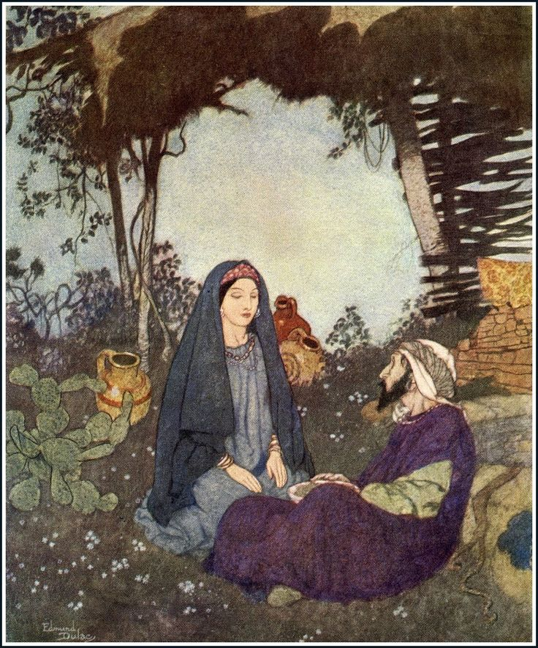

It is a fictional tragic love story.
Qays ibn aL Mulawwah was just a boy
When he fell in love with Layla al Aamrriya
In the Arab region in 7th century.
Layla was tender as a cypress tree.
She could slay the whole world with a flicker
Of her eye lashes with such a beauty.
She was known for her beauty in the school. 1

She was equipped with two lustrous eyes
And a mole on her cheek when she was born.
Whose heart would not have filled with longing
At the sight of the girl with such black hair?
Even the milk she drank has turned the colour
Of roses the skin on her lips and cheeks.
Qays was one of the best pupils in the class.
He fell for her and she, for him at once. 2

Qays had given his heart to cute Layla
Before he understood of what he gave away.
They drank by day and dreamt by night all along.
Glances were the marks that they were scoring.
Like musk deer, love is betrayed by its scent.
Their eyes were blind and ears deaf to the world.
Everyone knew that he was mad of her
And her parents took her home and kept in. 3

His heart fell ill, longing for his beloved.
Soon everyone knew that he was obsessed.
Qays had lost all chances to see her face.
Parents hid her away from his approach.
Layla hid her sorrow from her parents
And, when she was alone, shed lonely tears.
The separation from his beloved robbed
The youth of his home. He lost his balance. 4

At night he, when everyone was asleep,
Would steal his way to the tent of his girl,
Recite his poems of her and kiss the threshold
And would hasten back before the day dawned.
‘East wind! Be gone early in the morning;
Caress her hair and whisper in her ear.’
‘One who has sacrificed everything for you
Lay in the dust on his way to you dear.’ 5

Layla was a lute and Majnun, a viola.
One day he stole her vision in her tent
At night in front of a candle burning.
She seemed a fairy, Majnun wondered.
He was a fairy torch, Layla exclaimed.
Parents were perturbed in son’s madness.
They pleaded to the parents of Layla
To give her hand in marriage to his son. 6

‘Your son is so obsessed of my daughter
That the people call him Majnun – mad man.
How can I take a mad man as her groom?’
Said her father and withheld his daughter.
Majnun left his parents and ran away.
He wandered in the wilderness with hair
Falling unkempt about his face in despair.
He noted neither reproach nor sympathy. 7

From a bud to a blossom Layla has grown.
Half of an enticing glance from her eyes
Would have been enough to conquer many kings.
She was in secret when she looked for Majnun.
She was also burnt in the fire of longing.
However, she was married to Ihn Salam,
Against her wish and disregarding her wish.
Hearing Layla’s marriage, Majnun mourned. 8

His family eventually gave up hope
For his return and left food in the open.
Majnun was seen reciting poetry
To himself or writing it in the sand.
Some years later, Layla’s husband died.
She was not free yet to join her lover
As she was to grieve for her husband’s death.
They had been separated for lifetime. 9

Layla fell ill and died of broken heart.
News of Layla’s death reached Majnun ears.
He reached the place where Layla was buried.
He wept and wept and surrendered to the grief
And died at the graveside of her beloved.
The love story of Layla and Majnun
Is a tragic love, termed Kuwara love-
The love that does not succeed to marriage. 10

‘I pass by these walls, the walls of Layla
And kiss this wall and that wall.
It’s not love of the house that has take my heart
But of the One who dwells in those houses.’
June, 2020

Andal, the mystic (800AD)

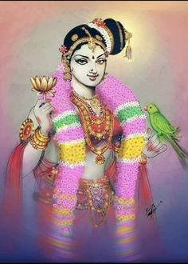

Andal is on literature, music and dance.
Andal is on drama, cinema and Margali.
Andal to Vishnu as Meera to Krishna;
Andal belongs to eighth century though.

Her unique hairdo is Andal Kondai.
Her massive garland is Andal maalai.
The parrot in her hand is Andal parrot.
Srivilliputtur is known for Andal.

Vaijayanthimala gave her a shape.
Ariyakkudi gave her verses a tune.
Vasanthakumari lent her a voice.
Andal is the pride of vaishnavites.

Parents unknown, Srivalli is revered.
Parents unknown, Sita is revered.
Parents unknown, Andal is revered.
They were made to be incarnations.
28.01.2018
(Andal fell in divine love for Perumal,
A form of Vishnu, and spent her life in devotion to Perumal
And at last she had been accepted as the consort of Lord Narayana, who dwelled in Srirangam. She refused to marry any human being and was in ardent love for Narayana. She has sung thirty songs to be sung at dawn to wake the lord on thirty days during Dec and Jan. )

Radha is an enigma (1100AD)

Is Radha a person or a concept?
Is she the milk maid or incarnation?
Is she a love companion of Krishna
Or a symbol of devotion for layman?

Radha is an imaginary figure,
Known through Jayadeva’s Gita Govinda
Written during the eleventh century.
No puranas prior speak of Radha.

Radha is Krishna’s love in the people mind.
Radha and Krishna in romantic love
Is portrayed by dance, folklore and painting
For the people to enjoy sexually.

Radha is not a separate entity.
Radha and Krishna form an entity.
Radha is not married to Krishna though
But her pure love for Him is outstanding.

The necessity of creating Radha
And her indulgence of love for Krishna
With sexual focus in devotion
Must be from tantric, sexually explicit.

No female creation was ever made
As cute as Radha, the epitome of love.
No dance can be with such sensual mood
As the one where Radha and Krishna romance.

No other Goddess combines the element
Of devotion and love so exquisitely
As does Radha in love shown to Krishna
Spiritually and physically.

Radha-Krishna relationship is holy.
Radha is seen as an individual soul
Longing for the Supreme for a merger.
Radha is found to be the quest of love.
Apr., 2019

Tristan and Isolde, a tale (1200AD)

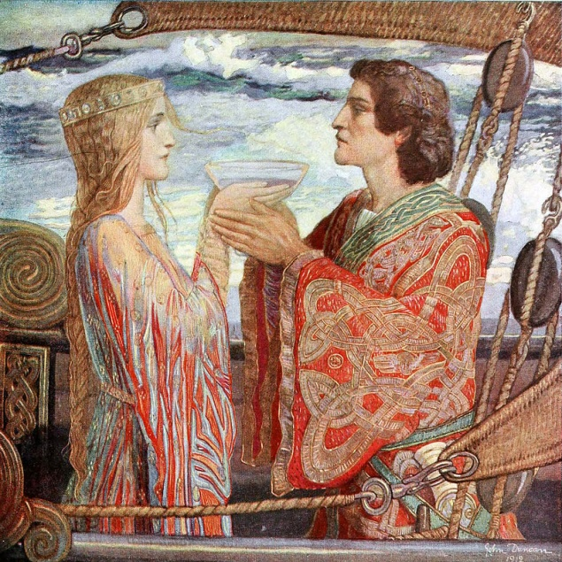

A high tale of Love and of Death is here
Of the knight Tristan and the queen Isolde;
To their full joy and to their sorrow too,
They loved each other and died together. 1

“Little son! I’ve longed a while to see you,
And now I see you the fairest thing born.
In sadness came I hither, in sadness
Did I bring forth, and in sadness has gone
Your first feast day. And as by sadness
You came into the world your name shall be
Tristan; that is the child of sadness, ho”
Said Blanchefleur , sister of King Mark, Cornwall. 2

Then she kissed him and soon after died.
She was left behind by her husband
On his way to wage his war and was killed
By Duke Morgan. Marshal Rohalt brought up
The child that grew well in fight and music.
Fate made Tristan reach King Mark through huntsmen.
Tristan took the harp and played it to Mark,
Who was pleased and took him as his liege. 3

Marshall Rohalt introduced to King Mark,
Tristan as his sister’s son much later.
The king of Ireland sent a champion
Morholt to demand tribute from Cornwall.
‘Lord King, by your leave I will do battle.’
Tristan fought Morholt in single combat
And killed him, whose wound bore his sword’s piece.
Morholt too wounded Tristan, his wound bleeding. 4

No doctors could heal, and he lost all hope.
He allowed himself to drift in a boat
Across the sea and in a week got the shore.
It was the same place where Morholt lay
And their lady was Isolde the Fair,
Who alone could save Tritson but wished him dead
When she discovered that he only killed Morholt,
And yet took pity and made him recover. 5

Anguish, King of Ireland, offered his daughter
In marriage to any knight who would slay
The fearsome dragon that was tormenting.
Tristan accepted the challenge not for himself
But for his uncle King Mark and killed it.
Isolde was coaxed by her father King Anguish
To go with Tristan to marry King Mark.
She set off with Tristan for Cornwall. 6

Isolde's mother had prepared for Isolde
To share with Mark a potion; they who drink
Of it together love each other forever
In life and death. One day in the voyage
Triston and Isolde were served the potion
By the maid for their thirst, thinking it as wine.
They were drawn close and he planted the first kiss.
Tristan and Isolde consummated their love. 7

‘Yet she is hopelessly in love with him
The King’s Nephew, knight and heir to his kingdom!
Forlornly she walks… her ermine and velvet
Cloak gathering the remnants of broken shells.
Oh God! She is sick from love…ravished by it!
Tristan’s scent, the taste of his lips upon
Her tongue, a remembered touch… Oh God!
She’d swoon if she recalled more of him.’ 8

When they arrived in Cornwall, Branwen, her aid,
Was introduced as Isolde and taken in marriage
To King Mark. The threesome managed to fool King Mark for some time but Mark found it out.
He challenged his nephew to a duel.
His nephew willingly lost in the duel .
As the treason should not go unpunished,
Tristan was sentenced to banishment, not death. 9

Tristan began a new life in a new land,
But remained faithful to Isolde for some time.
After a time, he met a beautiful woman
Also called Isolde, of the white hands.
He married her but never forgot his Isolde.
In a fight with six men to rescue a woman,
He got brutally wounded and sounded his wife
That only queen Isolde could cure his wounds. 10

His wife’s brother was entrusted with the job.
Tristan asked him to use white sales upon return
if King Mark released Isolde for this voyage,
And black sales if he did not. He agreed.
Moved by affection, Mark sent him his wife.
Not to lose him to his old love, Tristan’s wife lied
That the sail was black. Hearing it, Tristan died.
Arriving late, Isolde collapsed and died. 11

(This story was much circulated during 12th century, with different versions. Romeo and Juliet of Shakespeare must have been inspired by this episode with a background of history as far back as 7th century.)
Aug., 2019

Lancelot-Guinevere love (1300AD)

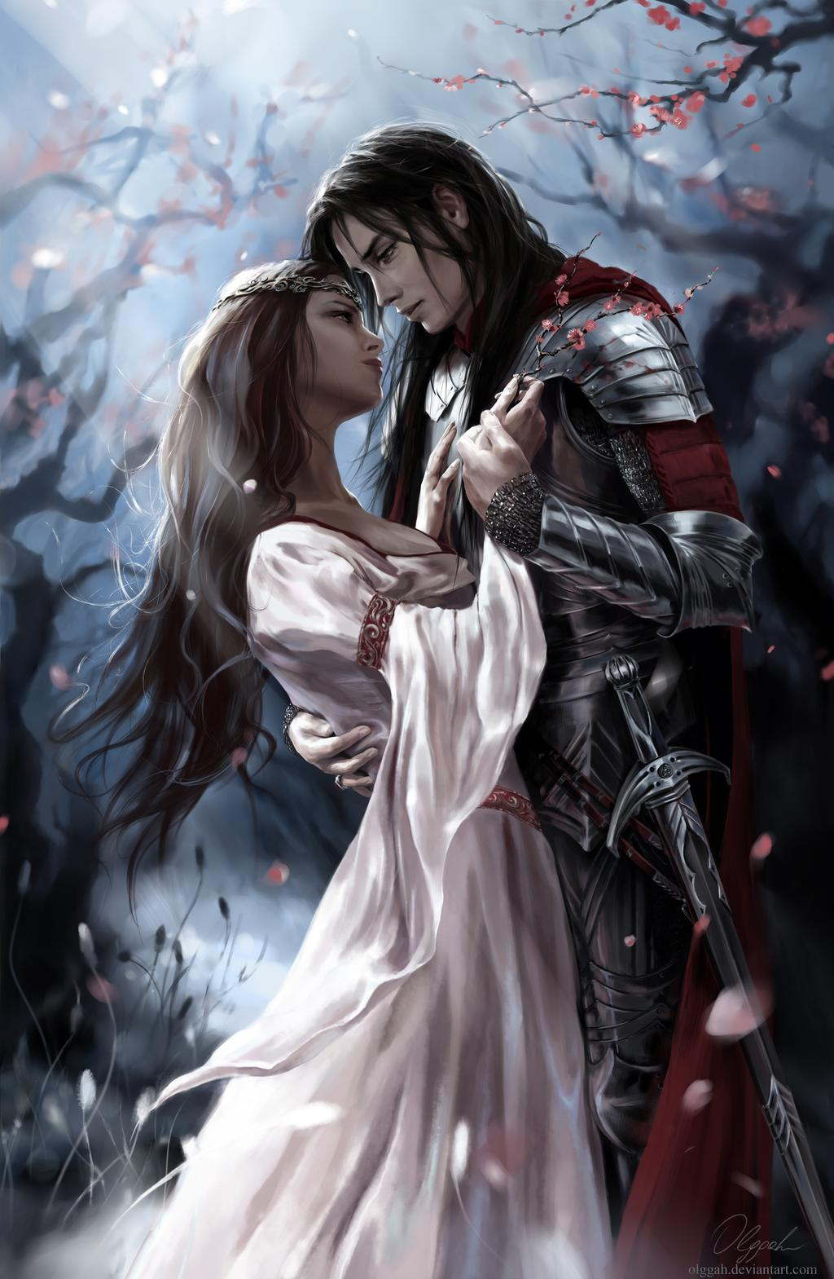

Guinevere was the wife of King Arthur,
The legendary ruler of Briton,
Who led the defense of Briton ably
Against Saxon invaders in the late
5th century and was hailed in folk songs.
Arthur married her, stung by her beauty,
In spite of a warning from his man Merlin
That Guinevere would be unfaithful to him. 1

Sir Lancelot was a knight belonging
To the Round Table and the most trusted
Knight of king Arthur in the battlefield.
He was known for his valour and posture.
When Guinevere was abducted by a design,
Arthur entrusted to Lancelot the job
Of undertaking a journey of hurdles
And fetching his queen safely from the spot. 2

Lancelot encountered many challenges.
He battled three axe bearing man squarely,
Lifted a heavy stone slab of a tomb,
Fought against an overly prideful knight
And crossed a bridge made with sharp swords.
He discovered Guinevere in the castle.
He fought men and broke into the tower.
He returned with her to reach King Arthur. 3

Guinevere acquainted with Lancelot,
Whose bravery and chivalry she was
An eyewitness to and was drawn to him.
A villainous and fatally flawed woman,
She was portrayed for the illicit love
She exhibited to the king’s knight.
Lancelot and Guinevere loved each other
And gave themselves to each other heart and soul. 4

Arthur took no notice of the growing
Attachments between the queen and Lancelot
In the very first, duly weighed by the trust.
The courtly love they ardently pursued
Lacked corporal lust and retained blushes.
The king accused his wife of adultery
And banished Lancelot, who left with heavy heart.
Eventually, the queen returned to the king. 5

Failing to produce an heir and unable
To be with her man, she went to depression.
Following the death of Arthur, the queen
Entered a convent and served as a nun.
The story of Guinevere was floated
Suggesting that women, the married ones,
Were expected to be high in moral
Than the men during medieval period. 7
June, 2020

Padmavathy, the queen of Chittor
(1300 -1400AD)

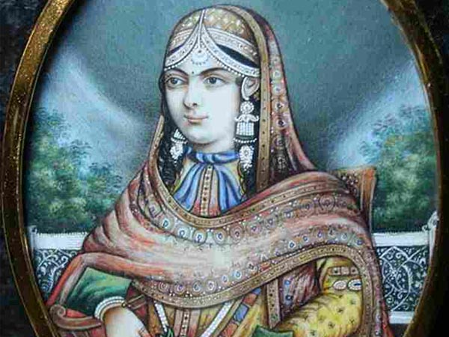

The tale about Padmavathi of Chittor
Has no base of historical evidence.
She is glorified for her chastity
And self immolation in defiance.

The tale of Kannaki of Poompukar
Has no historical events to back.
She is personified for chastity
And retaliation against misjudgment.

The epic around Seetha of Ajodhya
Has only mythological references.
She is epitomized for her fast virtue
And staunch resistance to guard chastity.

Padmavath is the pride of Rajputs.
Kannaki is the pride of the Tamils.
Seetha is the pride of most of Hindus.
All the three heroines are goddess equal.

There are many versions of these fictions.
All versions uphold woman’s purity.
The Hindi film Padmavathy must follow suit.
To stall its release by some is immature
Nov., 2017

Chittore Rani Padmini (14th century)

The legend of cute Queen Padmavati
Is a tale of lust and war, the tragic.
The epic poem of Padmavati was written
By Malik Muhammad Jayasi far back
In the early sixteenth century.
There are many versions of the epic
But all spoke of the beauty of the queen,
Lust of the Sultan and the glory of Rajput. 1

Padmavati, also known as Padmini,
Was the second wife by swayamvara
Of King Rawal Ratan Singh, who had ruled
Chittorgarh, also known as Chittore.
Padmavati is known for her beauty.
She was the daughter of king Hamir Sank,
The Chauhan ruler from Shingala kingdom.
Chittor Rani Padmini she has become. 2

Alauddin Khilji, the Sultan of Delhi,
Who ruled in the thirteenth century,
Heard of the beauty of Padmavati
From Raghav, a brahmin musician,
Who took refuge with the Delhi Sultan,
After he was banished from Chittore fort
For his indulgence in sorcery act.
He sang the queen’s beauty, to settle his score 3

Intrigued by the description of Padmini,
Alauddin marched with army to Chittorgarh.
Camping outside the fort, he sent a word
About his wish to see the beauty of the queen.
Not to upset the Sultan and invite his wrath,
Ratan Singh relented to the Sultan’s wish,
Which Rani Padmini declined from modesty.
Rajput queens cannot be seen by strangers. 4

Rani was coaxed to let her reflection
From a mirror be seen by Alauddin.
Smitten by the beauty from the mirror,
He decided to have her as his own.
Her husband was kidnapped when he saw off
The Sultan outside his fort and Padmavati
Was bargained for exchange of the king.
Gora and Badal came to the queen’s rescue. 5

In the name of Padmavati and her aids,
A hundred palanquins carrying soldiers
In disguise led by Gora and Badal
Reached Delhi and brought the king back.
Alauddin Khilji’s rage went out of bound.
Meanwhile, Ratan Singh was killed in a duel
With Devpal, the king of Kumbhalner,
Who also was enamoured with Padmini. 6

The Sultan army, unable to break the fort,
Laid siege on Chittor, cutting off supplies.
Many events took place and the fort fell.
Men dying in the battle, sensing the defeat,
Women in the fort, led by Padmavati
And Nagmati, the queens, committed jauhar,
By jumping into the huge fire pit set.
Alauddin got empty fort and the charred queen.
June, 2020

Anarkali (late 16th century)

The fictional tale of Anakali
And Salim has been adopted into arts,
Literature and cinema in India
From the late seventeenth century onwards.
The love story of Anarkali-Salim
Is the story every lover would know
And is invoked to refer to the love
For its intensity and purity. 1

Nar Ud Din Mohammad Salim to be known
By his imperial name as Jahangir,
The son of Akbar, Mughal emperor
During 16th century in India.
Anarkali, born as Sharif un-Nissa
And also known as Nadira Begum
Was a courtesan from Lahore region.
Anarkali means pomegranate blossom. 2

Anarkali was the renowned beauty
And the talented courtesan in dance.
Salim was the man of passion in art
And the man of sensitivity for women.
He fell in love with her for her beauty,
And discounted her birth as courtesan.
She knows that their romance was forbidden
In the eyes of Mughal Emperor Akbar. 3

Salim could not hold himself from her charm.
Anarkali could not hold him away.
The emperor could not digest the fact
That a prince was in love with a courtesan.
He sent words to her to stop the romance.
He threatened her with dire consequences.
The prince revolted against his father
But was defeated and sentenced to death. 4

Sensing the trend, Anarkali renounced
Her love to save her lover from the death.
Yet she was entombed alive for her love.
The love episode was in their teenage.
The heart broken Salim lived to be the king
In the year sixteen five and later married
Nur Jahan after seeing her widowhood.
Salim built a rich tomb for Anarkali. 5

The audacity to be in love
And the pain that is endured in the journey
Of it is special and relatable
To everyone who have ever loved someone.
The love that fears and has inhibitions
Is not love but it is lust and is a sin.
Love destroys the life and lovers are known
Only when they are dead, so be they dead. 6
June, 2020
Pride And Prejudice

Elizabeth, I fell in love with you,
Without seeing you in person.
Without being born in your days,
With a figure that I carved of you,
Out of manners written in words
By Jane Austin in Pride and Prejudice.
I have cut such a figure of you in my thought.
Like of which no heroine could match
If she were to enact you in a play.

You are the epitome of pride,
The pride without vanity,
The pride without humility either;
The pride with a royal aura
Without any royal blood.
You have had such pride as forbade
You even to reveal your love
To one you were deeply in love with,
And to one who condescended to love
Till he himself laboured to spell.

Elizabeth, I fell in love with you
For your pride, poise and composure.
Dec., 2004

Heloise (1079-1142) and Abelard (1101-1164) in love

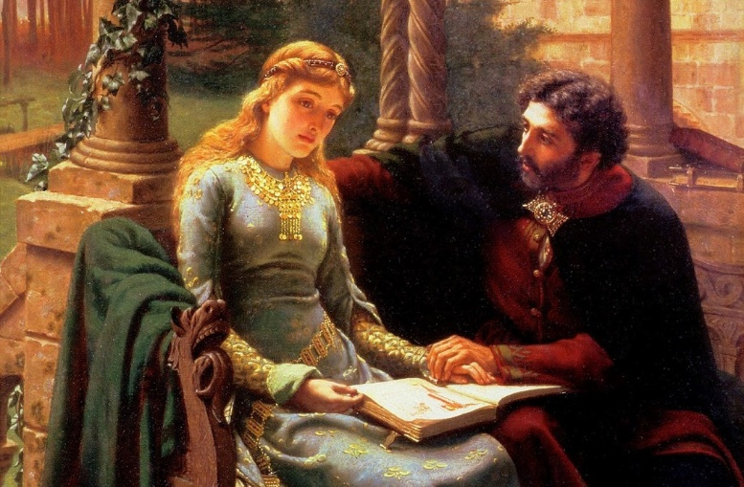

Peter Abelard was a French philosopher.
Heloise was the niece of Fulbert, a canon.
He was born in ten thousand seventy-nine
And she was twenty years younger to him.
He was teaching philosophy in Paris.
She was aspiring to learn philosophy.
Abelard must be 40 when he met her.
Heloise must be in her 20 to see him. 1

Heloise, of no mean beauty, stood out
Above all by reason of her knowledge,
Which was abundant, as much as her charm.
He wanted to teach; she wanted to learn.
Her beauty attracted him to teach her.
His reputation drew her towards him.
He wanted to have her so he taught her.
Fulbert consented his stay with them. 2

Proximity is a culprit for passion.
Their corporal presence in study paved
The way for him to advance upon her
And exploit her passion for having sex.
‘All men are under a necessity
Of paying tribute at some time or other
To LOVE, and it’s vain to strive to avoid it.’
He wrote in his correspondence about her. 3

He wrote, ‘Charming Heloise, said I, blushing,
If you know yourself, you’ll not be surprised
With the passion you have inspired me with.
There was a most happy understanding
Between us; the same house united us.
We improved the time with the sweet of love.’
Love is incapable of being concealed.
Abelard was obliged to leave her and the house. 4

He could not live without seeing Heloise.
He entreated her servant to help him
For money but attractive as she was,
She wanted him to have her his mistress.
So entirely did he love his Heloise
That he turned her desire down and left her.
Heloise’s singing master helped their meet.
Both had an ardent meeting in her garden. 5

The first news she acquainted with him plunged
Him into a distraction. She must be
Delivered of a burden she was feeling.
She was soon shifted to her sister’s house
In Brittany. It is a robbery, he felt,
Which love had made him commit and it was
A sort of treason. Next step he did was
Asking Fulfert’s pardon with confession. 6

He further offered to marry her in secret.
‘Will it not be more agreeable to me
To see myself your mistress than your wife.
And will not love have more power than marriage
To keep our heart firmly united?’ she told.
However, marriage took place in secret.
A boy was born and entrusted to his sister.
To hide marriage, she was sent to nunnery. 7

It was Abelard who kindled in her love.
It was Heloise who watered in her love.
‘I have your picture in my room and never
Pass it without stopping to look at it.
If a picture can give me such a pleasure,
What cannot letters inspire?’ she wrote,
‘I shall read that you are my husband
And you shall see me sign myself your wife.’ 8

‘You can only relieve me with tears and words.
I will still love you with all the tenderness
Of my soul till the last moment of my life.’
She wrote and reasoned against marrying,
‘The name of wife is hoourable in the world
Yet the name of your mistress had greater charms.
In marriage I am necessitated
To love always one who loves me or not.’ 9

Heloise is considered the first woman
In 12th century on feminist philosophy.
‘Happiness is the union of two persons
Who love each other with perfect liberty,
Who are united by an inclination
And satisfied with each other merit.’
She preferred to be known as mistress
Rather than wife and enjoyed that liberty. 10

He spent his time with monks. Fulfert mistook
Abelard to have abandoned Heloise as a nun
And got him castrated through his servants.
After castration, filled with shame from this,
Abélard became a monk, without retaliation.
It was at this time that they have exchanged
Their famous letters having literary merit.
They convey the remembrance of lost love. 11
June, 2020
(The Abelard-and-Heloise tomb is found in Pere Lachaise site in North East of Paris.)

Josephine Napoleon (1763 – 1814)

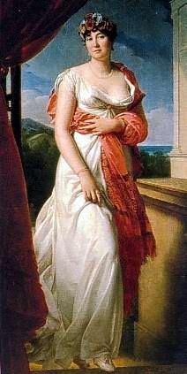

‘You shall be crowned the Queen of France and sit
On the throne by the side your husband.’
Said the priest astrologer when she was seven.
Josephine was then just a maid servant,
And was borne by a maid servant to her master.
She was given away by her father
To a French noble Viscount Aleksander
Beauharnais, who married her in ‘79. 1

Josephine in due course bore him a son
And a daughter. In French revolution
In ’89, her husband was guillotined
And Josephine was thrown into prison.
Paul Barras, a French General fell for her,
Secured her release and made her his mistress.
However, she failed to be his trustworthy.
She received other Generals also. 2

Her eye fell on Napoleon Bonaparte,
A promising young man still unmarried.
The widow invited Napoleon for lunch,
Where he fell completely under her spell.
They became lovers and her attention
Was diverted from Barras to his relief.
She shed crocodile tears to Paul Barras
And married Napoleon in ’96. 3

Josephine did not love Napoleon as much
As he loved her and it took her years
Before she warmed well to his affection.
He was mad of her and kept a picture
Of her in his pocket to kiss it now and then.
Not a beauty and well past her prime age,
If she bewitched him, it’s her hypnotic charm.
His love letters to her are the world famous. 4

While Napoleon languished in the battlefield,
Josephine lived in Paris, enjoying herself.
She wanted him for social recognition
And he wanted her for her hypnotic face.
He was in dark about her amorous
Escapades with her new lover Charles.
He realized that she had no love for him
And gathered himself to war and nation. 5

She was the first wife of Napoleon
And as well the first empress of French
When he became emperor in 1799.
Not trusted but loved, she was retained.
Napoleon made up his mind to divorce her
And marry a princess to bore him an heir.
He divorced her in the year eighteen nine
And married Marie Louise, who bore him a son. 6

Josephine was let to leave the place
With dignity with all jewels and fortunes
That she kept in the tenure of queenship.
She was not disturbed from separation.
She lost the sympathy of her children
For her debauchery and self-centeredness.
Napoleon was dethroned and exiled.
Josephine died, uttering napoleon’s name. 7
June, 2020

Barrett and Browning in love (1806–1861AD)
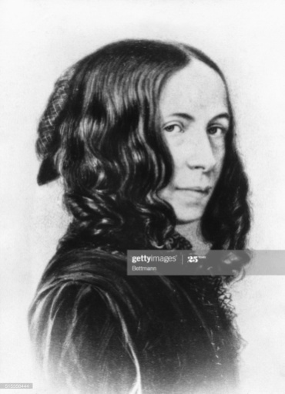

Elizabeth Barrett was a poetess
And Robert Browning, a renowned poet.
He fell in love with the poetry of her
And subsequently started loving her.

‘I love your verses with all my heart.’ Wrote he.
Her invalidation did not deter his love.
He loved her when she was at thirty-nine.
He loved her despite six year over age,

Her dark eyes and a large well shaped mouth
Were the features that attracted Browning.
‘When you came, you never went away.’
She wrote to him after his first visit.

She declined his proposal for marriage.
Her invalidation might ruin his life.
When she recovered, she eloped with him,
Fearing the wrath of her tyrant father.

They lived for sixteen years in Italy,
Both writing and living happily.
She died in 1886, leaning on his chest,
She had made a poem about her love for him,

‘I love thee to the depth, breadth and height
My soul could reach. .......................
........................... and if God chooses,
I shall but love thee better after death.’
Jan., 2018

Jane Digby- the pursuit of love (1807-1881AD)

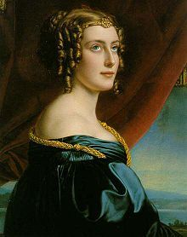

Born in 1807, lady Jane Digby
Was as romantic as of adventure.
Even at sixteen she turned the nobles on.
Her parents had counted on her beauty. 1

Her marriage with Lord Ellenborough,
A rich, thirty-year-old widower, failed.
She bore him a boy to make him potent.
She waned away and was sought by lovers. 2

She fell in love with Prince Falix.
Neither of them buried their secret.
A marriage with him could not be made
As he, a catholic, cannot wed a divorcee. 3

‘Jane Digby was’ Prince Falix acknowledged,
‘Among the greatest beauties of her time.
She had given up everything for him-
Fortune, reputation, friends, and family.’ 4

Tired of being admired, desired and sought,
She set of to see the rest of the world.
She became mistress of King Ludwig,
Whom she was fond of but not in love with. 5

‘Without love feeling, life is a dreary void.
Loving and being loved is air to breathe.’
With this in mind she fell for the Baron,
A Bavarian noble man, young and handsome. 6

He proposed but she was hesitant,
Thinking about her love for Prince Falix.
‘There exists something in a first passion
That no time can efface.’ she felt and wrote. 7

The king helped her marry the Baron,
Suspecting the seed, she carried as his.
But the child was the image of the Boran.
She bore him one more before she parted. 8

Count Theotoki, a Greek, was her next lover.
There were secret assignations with him.
She was required to choose between two men
Who wished to behave more nobly than the other. 9

‘No woman will ever possess me, dear,
As you have possessed me. A mistress
I will have but I cannot have another Jane.’,
Wrote the Baron, accepting her parting. 10

She went to live and love Theotoki,
Saddened at pain she has caused to the Baron.
Getting divorced, she married Theotoki
And stalled it after several years. 11

At sixty plus, General Hadji Petros,
Was attractive to women and the queen.
At forty-five, Jane became his mistress
And felt freer as mistress than as a wife. 12

Her last lover was Medjuei, an Arab.
He was fascinated by Jane from the first.
He presented to her a beautiful mare.
When he proposed, she accepted instantly. 13

She discovered that he had all the qualities
She had sought in other men. She exclaimed,
‘I’m forty-seven and as much in love
As a young girl of fifteen years old.’ 14

Jane and Medjuel married for thirty years.
It was a passionate relationship to the end.
‘Had I in early life married the Sheikh
I could not have caused so much grief.’ 15

In 1881 Jane died with him beside.
As the service in the cemetery over,
Astride Jane’s Arab mare, his gift to her,
He galloped away, gazing the coffin.

For her love mattered, which she sought in men.
Jan., 2018

Mata Hari (1876-1917AD)

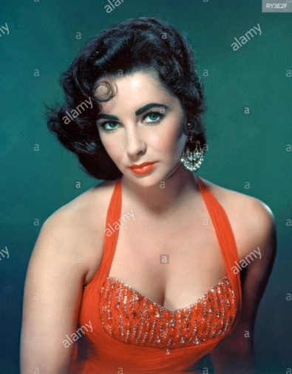

The seductive spy was Mata Hari.
Born in 1876, in Netherlands,
Found guilty of spying for Germany
By the French, she was executed
At her forty-one, notwithstanding her beauty.
Mata Hari, the exotic dancer,
Was not pure but might have been innocent.
Though a whore, an international woman,
She had been known as, in a euphemism,
An insatiable hunger for male attention.
Propelled by her sexual drive to make men slaves,
She lost her virginity to her Headmaster.
Her prey were mostly military giants,
In whom she found strong arms
And whom she found gallant and sweet.
A female fatale that she was,
The one who ordered for her execution
Must have been an impotent.
She had rocked Europe and wrecked heads,
With no one to rock her cradle nor her heart.
Aug., 2007
Mohammed Ali Jinnah’s fall (1876-1948AD)

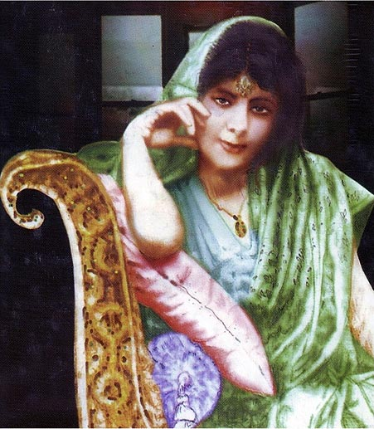

Jinnah,40, was hard pressed to ignore
Ruttie, 16, who wore gossamer-thin
Saris that clung to her subtle body,
And who had a ready flirtatious laugh. 1

He was her father’s good friend and his age,
And went to stay with him in Darjeeling
For a month to escape Bombay summer.
It was the summer of nineteen sixteen. 2

His age dissolved in his personality
And her age enhanced in her majesty.
A tendril had found a brown twig to cling to,
With proximity as the great culprit. 3

Jinnah was a Muslim and she, a Parsi.
He is a widower and she, still blossoming.
Sir Dinshaw Petit, a man of fortune,
Thwarted his bid to marry his daughter. 4

Her drive for her survived the denial.
Her fall for him survived the consequence.
They kept in touch in secret, and eighteen
Turned to, she eloped with him forever. 5

Jinnah and Ruttie scandalized Bombay.
A glamorous couple they became known,
Cruising down Marina Drive at sunsets
In his convertible, her hair loose in wind. 6

Soon she gave birth to a daughter, Dina.
Sooner she plunged into some mysticism.
The difference in age and temperaments
In them grew too obvious to ignore. 7

She died at 29, alone and lonely
In the Taj Mahal Hotel, Bombay,
By a collapse in a mysterious way;
Who knows it could have been a suicide. 8

She drove me mad; she was just a child and
I should never have married her, he told.
He packed away her jades, silks and all
And rarely mentioned her later in life. 9

Jinnah moved to London with Dina
And his spinster sister Fatima to live.
How successful Jinnah and Ruttie had been
In marital life is a question mark. 10
June, 2015
Edwina Mountbatten (1900 – 60)

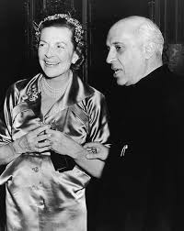

Edwina was patrilineally descended
From the Earls of Shaftesbury.
When Lord Louis Mountbatten met Edwina,
She was a leading member of London
Society and their marriage, which was held
In nineteen twenty-two, attracted crowds
Of the royal family with prime heads.
It was dubbed then ‘the wedding of the year.’ 1

Edwina was one of the most beautiful
Women In England, said Drew Pearson.
She was known to have affairs all her life
And did little to hide it from her husband,
She herself being ten times richer than him.
A disgruntled wife took Edwina to court
For her indulgence with the married men.
Hugh and Laddie were her serious lovers. 2

Edwina’s interests in India’s
Freedom struggles pushed her into the arms
Of Jawaharlal Nehru, a person
Of charismatic personality.
A man of passion and sensitivity,
Nehru found in her a kind of solace
That he hadn’t got from his deceased wife.
Edwin-Nehru love blossomed in forty-five. 3

It was from the hand of Lord Mountbatten
That the freedom of India was delivered.
Edwin was instrumental for its happening,
Which was because of her crush on Nehru.
Both of them were remarkable people
Needing each other with high intellect.
The volumes of letters Nehru wrote her
With love were preserved by Mountbatten. 4

Edwina had the chance of privacy
With Nehru when he visited London
Two years after India’s freedom.
She maintained live contact with India
In order to have Nehru’s company.
Whenever Nehru visited London
He stayed with Edwina and Mountbatten.
She often came to India to stay with him. 5

It was in sixty and Nehru was past seventy.
He invited Edwin for the Republic Day.
She had privacy with him during the stay.
It was her last meeting with Jawahar.
She left him without telling about her health.
Edwina’s death came soon and shocked the world.
Hearing it, Nehru was a broken man.
Homage was paid to her in the both houses. 6

Mountbatten knew that Edwin loved Nehru.
Indira knew that her father found a soul.
Vijaya Laxmi Pandit complimented her
Saying Edwin came to her brother’s life
When he had no wife and fulfilled the void.
‘The God or some fairy gave you beauty,
Intelligence, grace and vitality- great gifts.’
Nehru told her, recognizing her greatness. 6
June, 2020

A doe eyed Bengali beauty (1928-2014AD)

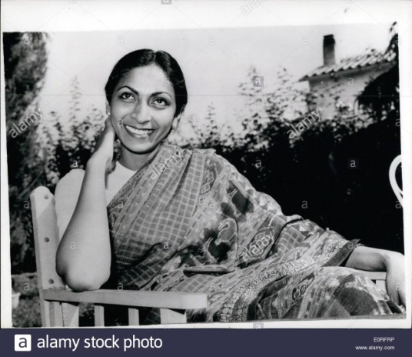

Sonali Dasgupta then
And Sonali Rossellini now
Passed away this week all alone,
At the age of eighty-four in Rome. 1

It was in nineteen fifty-seven.
A scandal broke of an affair
Between Sonali , 27
And Roberto Rossellini, 57. 2

The occurrence was in Bombay.
Blitz and Film India flashed the news:
‘To elope with Roberto Rossellini’
It became talk of the town all the way. 3

They flew to Paris and then Rome.
She took her second son, one year,
Leaving the other with her husband,
Harisadhan Dasgupta, a filmmaker. 4

A doe eyed Bengal beauty was she.
An aspirant of an actress was she.
She led a humdrum existence,
Playing a second fiddle to her spouse. 5

Her husband deputed her to assist
Roberto Rossellini, a celebrate
Film maker of Italy, in script writing
In his documentary of India. 6

Discomfited and yet flattened
By the attention Rossellini lavished,
She, 5’8”, succumbed to his charm
And slipped into her arm and then bed. 7

She had to desert her family
And elope, with no other way left,
As she had conceived illicitly.
She gave birth to a female child. 8

All the fifty years while she lived in Rome,
She dressed in saris and looked Indian.
She lived with elegance and grace.
Her estranged husband has later died. 9

Her second son died, and daughter fled,
Having converted to Islam.
Her first husband died in penury.
She died alone, aloof; who knows how? 10
June, 2014

Jacqueline Kennedy Onassis (1929 – 94)

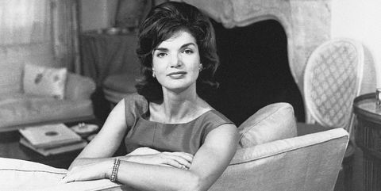

Jacqueline Lee Bouvier (Jackey) wrote a letter
To her fiancé John Husted insisting
To not give credence to the rumour
About her relationship with John Kennedy,
But she was wrong and had relationship
With John Filzgerald Knnedy, in whom
She found all she wanted to get in life:
Wealth and the heart to let her spend as she liked. 1

She broke the engagement with John Husted
Without remorse and gave him back his ring.
She had an uncanny foresight to hook
The right man from wooing two at a time.
She married John Kennedy in ‘fifty-three
And became the first lady of US
In ‘sixty when he became President.
With that came the pinnacle of her life. 2

Jackey became an international icon
For style, elegance, poise, and extravagance.
‘Mr. President is worried about
My budget more than that of the US.’
Said Jackey, and John Kennedy once said,
‘I am accompanying Mrs. Jacqueline Kennedy.’
On French Paper heading about her visit:
‘The US first lady is beauty incarnate.’ 3

Jackey came to India on a state visit
And charmed Indian PM. J. Nehru.
She too was impressed and drawn close to him.
She had acquaintance with Aristotle Onassis,
The Greek tycoon on his luxury yacht
To negotiate marriage of her sister Lee
To Onassis who found interest in her.
Onassis forgot Lee and fell for Jackey. 4

The president was assassinated
And fell on his wife lap in ‘sixty-three.
She meanwhile bore for him a girl and a boy.
In her widowhood, Robert Kennedy,
For whom Marlin Monroe fell, though in vain,
Was the chief and close supporter for her.
Had he not been assassinated later,
Jackey would have remained as a widow. 5

Jackey married Onassis in ‘sixty-eight.
A sense of estrangement set on Onassis
From a leakage of her personal letters
Made to her former escort and lover,
Roswell Gilpatric in nineteen seventy.
Onassis was getting alienated from her,
And died in seventy-five, for Jackey
To get second widowhood without regret. 6

Jackey had several male companions.
And her quest for third husband was alive.
Maurice Templesman, a known associate,
Was her life companion when she celebrated
Her sixty first birthday in ‘eighty-nine.
She had kept herself remarkably young.
Jacqueline liked to forget all tragedies
And lived in peace, pleasure and opulence. 7
June, 2020

Prince Margaret ever young. (1930-2002AD)
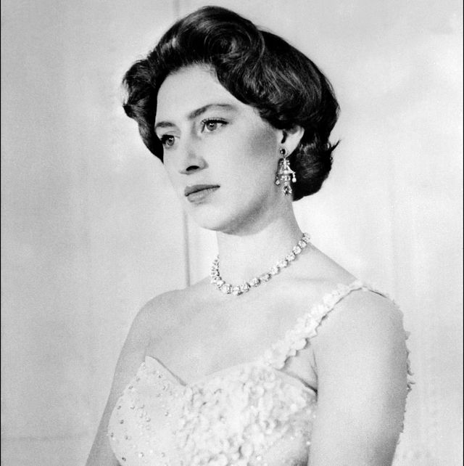
As younger sister of Queen Elizabeth
And daughter of King Georg VI of England,
Margret Rose was born in nineteen thirty.
As freedom seeking and pleasure loving,
With a sematic beauty coupled with
The Lucite complexion, has she grown up.
As could be like any bohemian girl,
She was an amalgam of Elizabeth Taylor. 1

A handsome world war II flying hero
Was Group Captain Peter Townsend, who was
Aid to Margaret’s father King George VI.
He, a divorcee, was the first person,
On whom Prince Margaret developed a crush
In her mid-twenties and much intended
To marry him, which the church didn’t sanction
As the marriage was to him, a divorcee. 2

She wanted to marry the man she loved
And didn’t mind giving up her claim to the throne.
It was her mother Queen Mary who forbade
Her from marrying him and losing the grace.
Margaret sublimated her libido
In dancing till late at night in the clubs
And dipped into London’s bohemian circles.
Townsend married Marie Luce years later. 3

She stumbled upon Antony Armstrong Jones,
A photographer, well educated
And a trendy fast living commoner,
Who dared to court Margaret instantly.
She liked his looks and admired his works.
Her mother found in her happiness and joy
After many years and gave approval.
She married him at her age of twenty-nine. 4

In due course of time she gave birth to a son
And a daughter with life not much rosy.
Margaret unresolved love for Townsend
Was dormant in her heart and her husband
Loathed all formalities of royal life.
Tony, her husband, later broke away
And invited most glamorous women
To spend nights with him in some cottages. 5

Margaret felt humiliated by him
There were many suiters to Margaret.
Lord Patrick Lichfield, a photographer,
Was one of them. Dominic Elliot
Was the other, whom she knew before
She knew Townsend, and she moved close to him.
Her other friends were Derek Hart, a TV man,
And Peter Sellers, the well-known film star. 6

Margaret met in Scotland a wealthy son,
Roderic Llewellyn in ‘73
When she was 43 and he 25.
She had good time with him in many ways
And he was much mad of her company.
Margaret-Roddy affair became public.
Queen Elizabeth stepped in and resolved,
‘The two mutually agreed to live apart. 7

Separation brought the princess freedom.
Her obsession with the pleasure of life
Did not slow down with her advancing age.
Like Elizabet Taylor, Margaret loved dancing.
Armed by wealth inherited by her mother,
She lived a queen life, engaging herself
In various social organizations.
Even at 60, she had friends her sons age. 8
02.07.2020

Divorce and remarriage (1932-2011AD)

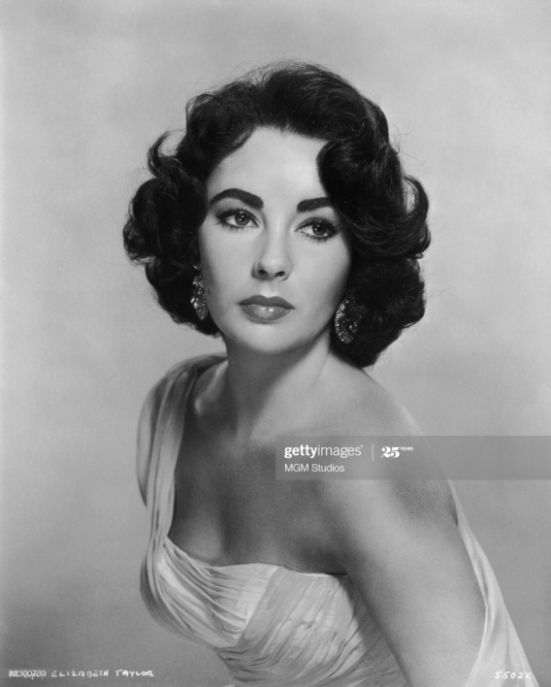

Elizabeth Taylor and Richard Burton
Fell in love in the set of Cleopatra,
As ardently as queen Cleopatra
And General Mark Antony in the play.
She was twenty-eight and he, thirty-five.
They had been in love scandal for four years
By when they divorced their spouses and married.
They had been married just for ten years,
Of which the latter half made them estranged.
They divorced in year 1974,
To be married again after a year,
Which did not last more than a year.
He was her fourth and fifth husband of eight.
He was the one she was drawn to most passionately.
She died in 2011 as a divorcee
And he in 1985 as a divorcee.
In spite of passion, love and position,
They could not be a happy couple.
Feb., 2016

Sophia Loran (1934AD)

‘Shophia Loron, the majestic,’
To say of you, I am apologetic.
You were born low, as illegitimate.
Your mother made you legitimate.
It is your mother who made you the great.
Her love for you was total, and vital.
Carlo Ponti was, who made you the screen queen.
Older by twenty years, he was mad of you.
He could not coax you to be less than a wife
He had to give up his family as price.

In Hollywood actor, Cry Grant,
You found your love and warmth
But it is Carlo who got your warmth.
You had to yield as a grateful dog.
You never changed husbands unlike Monroe.
You never betrayed your husband.
Nor did you sell yourself for wealth and fame.
Your two sons are legitimate,
By which you rank high in estimate.
Your mate is the most fortunate.

You seduced attention all over.
No worthy man could lay hand on you,
The poorest of poor, who grew the richest of rich.
You were not the queen of Rome
But you swayed as the queen of celluloid.
You were honoured with Mrs. World,
For consistency at your five and sixty.
As much you barred men as you lured-
A lover of gratitude and solitude,
A symbol of honesty and majesty.

A blend of beauty, love, and culture,
You last by your inner beauty.
You still exist so no scandal is thrown.
May, 2002

Ratna Sari Dewi Sukarno (1940AD)

First President of Indonesia
Was Dr. Bango Kamo Sukarno,
Known for his love for women and wine.
During his foreign trips he was keen
To meet the best of women with wine.
On a state visit to Japan, he went
In the year of nineteen fifty-nine’
Where he was introduced to a lady. 1

By Naoko Nemoto’s exotic beauty,
He was fascinated and fell for her.
She was a bar hostess and at nineteen.
He was 58 and got a good treat.
Sukarno and she fell for each other.
He found in her a source for his passion.
She found in him a way for fame and wealth.
He later married her as his fourth wife. 2

He renamed her Ratna Sari Dewi,
to suit the Indonesian language
After she converted to Islam.
With her marriage to the President,
She became the First Lady of the land,
And moved to a palace built for her.
An oil painting of Dewi in westen clothes
Was hung on the wall of the drawing hall. 3

Ratna led a luxurious life and enjoyed
The power of her husband in all manner.
The interest of Japan was always
There in her heart, and she made a huge wealth
And put it in the bank of Japan and Swiss.
She lived in her villa like a queen
And built a bridge between her man and Japan.
She was keen that her husband was in power. 4

In the meanwhile, a military coup
Under Gen. Suharto was staged
And Sukarno was made a captive head.
His twenty years of rule as dictator
Came to an end to the plight of Dewi.
She came there to marry power and wealth,
And was not ready to wilt with her husband.
To flee Indonesia was her option. 5

Dewi was pregnant. Under the pretense
Of delivery, she left for Japan.
Her husband had built for her villas
in Djakarta, Paris and Tokyo.
She went away to enjoy the life
Of luxury in Paris for two years.
She gave birth to a daughter in Paris
And named her Kartika Sari Dewi. 6

Once she thought of returning to her husband
But left it for fear of prosecution.
She expressed grief over the fate of him
And gave him up for good in her rest of life.
During Dewi’s stay in Japan, she made
Friendship with one Masahiko Tsugawa,
The famous film star and kept his company.
She, not a divorcee, could not marry him. 7

Sukarno fell ill and his wife returned
With their child for him to see his product.
He laid down his life in their presence
In nineteen seventy, when he was sixty-nine.
‘I loved her as the jewel-essence. Instead
Of being the jewel-essence herself, jewels
Had become the essence of her life.’ said he.
A well-known media figure she is now in Japan. 8
June, 2020

Marilyn Monroe. (1945-62AD)

A tragic angel of sex,
A seductive child woman,
A legendary Love Goddess,
A blonde, a beauty persona,
A voice as much voluptuous,
You, Marilyn Monroe,
As betrayed by those who mattered you,
And ill-loved by those who you mattered,
Having taken over doze of sleeping pills,
In 1962, a fateful year of sex hunters,
At the ripest age of six and thirty,
Over the failure of much cherished
Marital bond with Robert Kennedy,
Had left us high and dry as sex starved.

From a poor soil and from a broken home,
You came out as an illegitimate child.
You were not to die as an invalid.
You found that your body was an asset,
With which you wanted to bet the world,
With which you wanted to take revenge
On all men, low and high, who fell by.
You had slept with many,
Even for a paltry sum.
You sold yourself for your need and growth,
Never for lust. You are not a man hunter.

You were deserted by three husbands.
You were belied by Robert Kennedy.
He wanted your body, not the soul.
You purred everyone to lust you and burst.
You used sex as a powerful weapon
To fight with and to beat with,
For the rise to the mount to humble men.

You sought love nowhere.
You lost it everywhere.
Love hungry and name hungry,
You were too fast to find love anywhere.
You had tuned up for men atop.
Had you turned down to fans below,
You could have got fountain of love.
I take pity for your sad death.
The solace is that I had my youth
Before you had had your last breath.
Your erotic profile still is in my memory.
A woman of sacrifice is Marilyn Monroe.
May, 2002

Hollywood, a catching pouch

Actress Gwyneth Paltrow:
He offered me the lead role in Emma.
He put her hand on me that suggested.
I was young; I was at this petrified.

Actress Rosanna Arquette :
He hired me for a role in his make.
He took me to his room for a massage.
I was in youth; I was at this mortified.

Actress Angelina Jolie :
He made an unwanted advance on me
That I thwarted in a private meeting
As I had had a bad experience in youth
When I worked for him in a production.

Actress Heather Graham:
He propositioned me,
Offering me a role in a movie
By saying his wife has let him
Sleep with other women outdoor.

Actress Lea Saydoux:
Weinstein's lurid behaviour
That i wrote in first person
Along with my bitter experience
Fell on deaf ears in Hollywood.

Cara Delevingne:
He is a ruthless sexual predator.
He sought on one occasion
To engage an actress in a threesome
With another woman shamelessly.

Ashley Judd:
He in a hotel room asked me
To watch him shower
And repeatedly suggested
With unwanted contacts to me.

Rose McGowan:
Following an encounter with him
In a hotel room during a film festival,
I reached a settlement with him.
Some others too reached settlement.

Lucia Evans:
In 2004, at his Miramax office
He was in the room alone,
And forced me to perform oral sex on him.
She said no but was overpowered.

Producer Harvey Weinstein:
I haven't entertained any actress
On a nonconsensual sex basis.
I haven't retaliated against the ones
When they have rejected my advances.

To demand sex in exchange of one's wants
Is sex exploitation and hence harmful.
To compromise sex for an aspiration
And later allege harassment is vengeful..
11.10.2017

Apples cast off (1975AD)

The tucked in apples were cut and cast.
The focused apples were cut and cast.
The craved apples were thrown as waste.
The coveted apples were thrown as waste.

The boys were sorry more than the gardener.
The boys were sore more than the gardener.
Before their decay, they have been thrown out.
Before their term, they have been cast away.

Breasts are the assets for any woman.
They serve as two way traffic of passion.
Without them stays not femininity.
To forgo them is an act of bravery.

They have been cut off by a surgery.
She has done it, before their expiry,
To cut the risk of cancer, a bold act.
Her grace is not lost but high in the mast.
28.05.2013
[Angelina Jolie, at her 37, got both mastectomies, to cut the risk of cancer]

Visalkshi the withered love

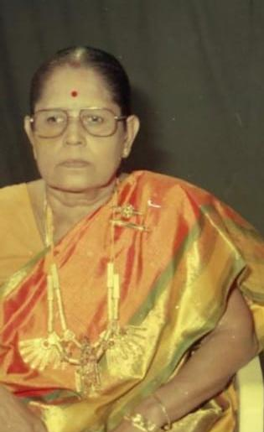

Paganeri Episode (1965AD)

Over thirty years, you had been in my Brain,
With teenage image in tender plumage,
So romantic, so smart, and so receptive,
In talks, deeds, and walks, to hold me captive
Till I saw you, from pain and sorrow,
To only find how withered you became
So dull, so sluggish and so over aged
In talks, looks, and walks to my dismay.
With remorse I wish I didn’t see you.
You would have stayed in me what you had been.
Unromantic mate, you had fallen to,
Like a parrot perking on a thorny plant.
I know your value; yet I missed you.
I could have kindled and preserved you.
No amount of regrets could absolve me
Of the cheat that I’d committed on you.
I repent and repent for my own shake.
A diamond had been burnt to a carbon.
01.05.2002

Vishalakshi

Her husband is dead.
Tragic or pleasing news!
That too in a car accident.
She was my love five decades back.
Our sojourn was a month
In her village where I chanced to stay.
Loveliness and gracefulness
Combined, she was a lotus.
No wonder, I loved her.
It is wonder, she loved me.
She loved me more
Than I loved her, the poor.
Her love was pure and genuine.
My love was daring and fast.
Our eyes crossed and then talked.
Our lips talked and then touched.
It is the virgin love for the both.
She sanctioned my visit once
To her house and to the room
Where we were closeted.
She believed me to such extent
That she conceded to be undraped
And surrendered to my trust.
Too tender in age, I deserted her.
It took three decades for me
To trace her and meet her.
Then she was not a lotus
But reminded me of a cactus,
Aging being prominent.

Now she is a widow.
I am not a widower.
Otherwise, I would have wiped
The sin I committed to her.
31.12.2007
Visalakshi-2
Her husband died of a car accident.
It took place about three years ago.
Now she is free of encumbrances.
Hence, I could talk to her as freely as
I did fifty-two years back in her village
Where I met her, where we fell for each other.
I managed to get her phone number.

The last meeting of us was in her house
With her spouse, some twenty years ago.
She has married seven years after
Our episode, in the year I married,
Both being unaware of each other.
I saw her there after thirty- two years
By when a lemon skinned beauty queen
Has turned into a dry skinned wrinkle.

I got her over phone and shared her grief.
She was upset, implying her bond with him.
She declined my offer of any meeting,
However incidental it might be.
‘Let us forget ours as a child game
With no renewal at this stage and age’
She said. Anxiety driven, she enquired
About me and family and my life.

Now she is seventy and weak as she told.
She is as old as me who am still robust.
It means we both were sweet seventeen
When we loved each other that went to
Being together with clothes stripped of
In her bolted room with a resolution
To elope, till we were caught red handed.
How quick a woman vomits her ex-lover!
24.06.2010

Visalakshi

Visalakshi is under dialysis.
I heard and enquired over phone.
She displayed no attachment.

Her son family met a car accident.
I heard and condoled over phone.
She displayed no attachment.

After her husband’s death in a car accident,
When I condoled to her over phone
She displayed disinterest.

It is written on the wall
That she is not inclined to resurrect
Our love aborted fifty-five years ago.

Her virtue is commendable.
My lingering love is rejected.
I am proud I’d loved such a woman.
05.06.2013

Ex-lover is a stranger.

He located her after two decades,
Putting so much effort in his wide search.
Having done it, he befriended her spouse,
Making it casual and incidental.

He and she were in deep love in their teens.
They loved with an intention to marry
In spite of his lack of supporting stage.
Against their wishes, love was aborted.

His love for her has neither dried nor died.
She felt about his sexual consciousness
When he moved about in her company
And told him not to visit her anymore.

Man does not have right towards a woman
Because he had her once as his beloved.
His approach to her with sex in his eyes
Is as good as a sexual harassment.
08.01.2014

Visalakshi 4

She herself that day called me up,
That she never did hitherto.
She got my number from one,
Being her confident and my friend.

Given to know about my health
Affected by deadly cancer,
She was tempted to contact me
Which she never thought of doing before.

She was at ease as much as she was
During our sojourn of love
Enacted when we were sixteen,
About fifty-seven years ago.

I gathered courage that I couldn’t
In earlier opportunities
To confirm the news that was gnawing
At me all fifty-seven years.

‘She fell into well from love failure’,
The next day after we were caught
Red handed in her room by mother,
Was the news I heard when I left.

She confirmed it as true in a tone
To show me how deep she was hit
By the failure I inflicted.
Her suicidal attempt put me dry.

She consented to my offer
Of visiting her in her abode,
Which she’s never encouraged so far.
It shows she couldn’t put down her urge.

The spark of love I ignited
In her as a maiden love has stayed
In her for the past forty years
Of family and her widowhood.

She is a widow, but I am not.
Even if I were a widower,
We cannot reunite by body,
In front of our descendants.
07.06.2014

Visalakshi V

It was her maiden love and his was too.
They conceived it and lost it in their teens.
She had buried her love from her husband
And ignored her lover since marriage.
As a widow, she keeps him still at bay
As she wants to bury it from children.
He stands barred and wilts over five decades.
Split love like glass, is not pieced together.
30.09.2014

Visalakshi- final

He and she fell in love at seventeen.
It was their maiden love and maiden kiss.
Such a graceful girl he hadn’t seen before.
She fell for him in a total surrender.

An oval face, yellowish skin so soft,
A smart walk, intelligent talks so sweet,
And a simplicity turned modernity,
She made him her slave to become his slave.

Seven years later, they married severally,
In the same year, unknown to each other.
She went out of trace and out of pursuit.
Twenty two years off, he’d an itch for her.

As a detective, he located her,
By when she was a mother of four kids,
A girl and a boy yet to be married.
Revival of contact was established.

At sixty-six she lost her husband killed
In a car accident, and her widowhood
Didn’t encourage shortening the distance.
Later she fell to a kidney failure.

She died at her home at her seventy four.
A light that kept him on constant focus
With delight and regret was off yesterday.
He felt he’s a widower at her death.

Her mother was the only eye witness
To the episode and no one else since then.
The episode was unborn to her spouse
Or any later; be it so forever.
26.07.2015

Visalakshi - The End

On a visit to that tiny village,
Whose name is always romantic to me,
I relocated the house to my thrill
After the lapse of sixty long years.

The girl of this house was my maiden love.
The love that blossomed was just a month old.
In the first visit she entertained me
With warmth that culminated in kisses.

In the last visit we were closeted
With the freedom of being without clothes.
She gave me herself governed by the trust
And yet refused to lose virginity.

We were in the small floor led by a flight
Of stairs bound by doors from the verandas
That encircled an open yard inside the house.
The cell had a window throwing light on us.

Intimate chats took us for many plans
Till the stair door was knocked at to our shock
And we were caught red handed by her mother.
Her mother let me have a quick exit.

Next day i was sent to my native village.
The same day morning she fell into the well
And was rescued, I came to know later.
Both were seventeen then, I knew far later.

Seven years later in the same year
Both were married severally
Without knowing by either of us.
I met her with her house thirty years after.

She died as a widow from kidney failure.
Till her death she was cautious at all cost
That her children get no iota of doubt
About our relation by keeping me out.
June, 2018
(In the photo on the side wall, on the second tire row, the second window was the one which let the sunlight fall on our naked bodies

)

end

Sexual Hypocrisy

There is an inner urge
In flowers to seek bees,
In fruits to seek birds,
In herbs to seek cattle
And in female to males.
Woman is no exception.
Her resentment to man
Is to display chastity
And suppress sensuality
To earn parochial approval.
Oct., 2018

6. ON SEXUAL ACT(A)

Then Even Death Is Worth. [A]

Let me come now to your fortress,
Having blinded your inmates.
Let me encounter you at your door,
And take you by arm to your room,
Where let me strip you of your shyness
Along with your blouse and skirt
Against all your seemly protests.
Let me rove your tiny breasts,
Narrow thighs, compressed groin
And pubes to be followed by tongue.
My claws on the imprisoned breasts,
My legs a pillory to lock your legs,
Let me toss you up and down to heaven.
Let me seal your thirst of lust
And put me to rest of quenched lust.
Of consequences be even death.
Jan., 2003

The Invented Sex (A)

All mammals have posture 66
In their sexual union
And man alone has posture pq.
Man’s invented one is 69,
Where each serves the other
To equal immense sensation.
Jan., 2006

Imaginary rape # (A)

Any woman, the observation worthy,
Be in T.V., movie or in person,
Never escapes man’s rape in imagination.
He unwraps her breasts, surveys their shapes
And exposes her blush, kindling her lust.
He arrests her head, presses open her lips,
And betrays her shyness, burning her pulse.
He rips through her thighs, toss her up and down
And destroy her shame, wetting her mount.
He will feel he has conquered and raped.
June, 2006

She Must Touch Mine. (A)

I must touch the woman to grow erotic;
No need that she should.
I must kiss the woman to grow erotic;
No need that she should.
I must feed on her, biting and licking.
The only arena
Where she makes me erotic when she takes
Mine in her palm and mouth.
Jan., 2006

Sexual Feedings

When eyes survey, when palms cup,
When mouth licks and when piston pumps
Man eats his lust from woman’s body.
Woman eats her lust from man’s feeding on her..
Dec., 2009

The Old One Is Expert. #(A)

I bring my sexy buttocks;
Them, boys don’t know how to act on.
You, the aged, must be an expert.
Turn me around and ride.

I bring my two sexy breasts;
Them, boys don’t know how to handle.
You, the aged, must be an expert.
Hold me under and kneed.

I bring my hot rosy lips;
Them, boys don’t know how to padlock.
You, the aged, must be an expert.
Lift me up close and bruise.

I bring my burning lobes;
Them, boys don’t know how to pound on.
You, the aged, must be an expert.
Lay me on bed and tear.

I want a long, hard foreplay;
That boys aren’t patient to employ.
You, the aged, won’t be in hurry.
Bring me to orgasm and cheer.
Sep., 2006.

The Value Of Kiss(A)

An erotic kiss is close to intercourse.
A woman’s lips symbolize her private part
And a man’s tongue, his private part, in their minds.
His hygiene and skill promise her a good course.
Mar., 2008

Man Made Devices (A)

Woman:
Than when under my insipid handling,
The sensation I got was far exciting
When I was raided in bed by a lad.
Man:
Than when under my insipid handling,
The sensation I got was far thrilling
When she took mine in her fist and did.
Woman:
Than when under his wild penetration,
The sensation I got was far sleeping
When he moved with his tongue instead of his.
Man:
Than when under clutch of her lower mouth,
The sensation I got was far stupefying
When she got me by her upper mouth.

Man made devises are substituting,
Ventilating and exhilarating
In the place of natural devices.
Oct., 2009

The After-glow (A)#

Human sex differs from animals,
In that it is a languorous affair
Involving a good amount of foreplay,
And simmer of lust and passion
Until the explosive culmination
And its post coital after-glow,
With no aim for fertilization.
Jan., 2007

Man’s Technique (A)

Excitement is the first stage through which
A woman passes in man’s foreplay,
Her sexual glands being stimulated.
Plateau is the second stage to which
She sails with the fast heart beats together
With breasts swellings and bottom wetting,
In the course of man’s motion upon her.
Orgasm is the third stage on which
She claims following the sustained action
When her vaginal and pelvic muscles
Grow tense and subsequently contract.
Resolution is the final stage
When her heat subsides, her heart beats slow down
And the muscles relax to calm her nerves.
Man’s failure will cost his hold on her.
Oct., 2009

Man’s Hand and Mouth (A)

Man employs his fingers on her body,
By which a woman is fed.
He employs his mouth on her body
By which he himself is fed.
Man is a creator-cum- consumer
Of pleasure in a fore play.
Nov., 2009

Her Expression (A)

She lets her eyes
Travel and wander
To meet his eyes direct.
Her pupils widen and shine.
She undergoes sexual love.

Her eye brows rise;
Her eye lids half fall.
Lips parting, the jaw lowers.
Muscles grow tense.
She undergoes sex itself.
Apr., .2010

Which is the Sexual Feed?(A)

She waits for me and I enter the room.
I undress her and she blushes.
I embrace her and she struggles.
My kisses and bites produce cries.
Pinches and licks make her writhe.
Into her when I toss she moans.
I find my sexual feed from her
Not in my manipulations of her
But in the reactions they make in her.
Watching her reaction is my pleasure
Rather than my devouring her flesh.
Feb., 2010

The Face is Value Giver.

To know which breasts are lovely
From the two pairs looking alike,
I must know whose breasts they are.
The breasts owe their value to their face.
Jan., 2010

Trans-placement of Sex

Breasts were kept out of sights;
Cleavage grew prominent.
Groins were hidden with clothes;
Naval became distinct.
Mating across is denied;
Masturbation has taken its place.
Induced by the sight of
The cleavage and belly
Coupled by masturbation,
Man sheds his interest
To have sex with women
As people, having watched the cricket
From television, have lost
Interest in seeing it in person.
Feb., 2010

Sexual Impulses

Woman tempts; man is aroused.
Impulses urge; fear forbids.
Their tussle results
In molestation or starvation
Or sublimation or masturbation.
Sep., 2009

Man’s Service to Woman(A)

Woman! I’m happy when you make me happy,
But happier when I make you happy.
I am happy when you kiss me
But happier when I kiss you.
I am fed when I feed on your body
But more fed from seeing your body’s writhing.
Man’s service to woman is unparallel.
May, 2010 .

Fist and Thumb(A)

The fist to man and the thumb to woman
Are the sex-gratifying devices.
Even in mating they use these devices,
His thumb for her and her fist for him
Either to replace or stimulate the coitus.
July, 2010

Habits have no Eye for Merits(A)

I cannot afford to buy whisky.
I am settled with the country liqueur.
Used to it, I lost taste for whisky.
The whisky offered was put aside.

I cannot risk taking women to bed.
I am settled with masturbation.
Used to it, I lost taste for sex.
I have my mate masturbate for me.
June, 2010

